Date: -27/10/26
CO-2 Assessment-3
ERROR ANALYSICS
Course Code: -DSA 0308
Course Name: -Natural Language Processing
Name: -A.V. Ameya Reg no: -192472036

QUESTION 1: Morphological Analysis Error in a Biomedical Dataset
Aim
To identify stemming errors in biomedical text using Porter Stemmer and understand their effects on information retrieval accuracy.
Introduction
Morphological analysis is an important Natural Language Processing (NLP) technique used to study the structure of words. In biomedical applications, it helps search engines identify related terms in medical reports and research articles. Porter Stemmer removes or modifies word endings to reduce vocabulary size. However, it may produce incomplete stems or remove important semantic information.
Error Analysis
Words such as infection, infections, infectious, and infected are related but have different grammatical forms and meanings. A stemming algorithm may reduce these words incorrectly or produce inconsistent stems. Such errors can prevent search engines from retrieving all relevant medical documents.
Inflectional and Derivational Morphology
Inflectional morphology changes the grammatical form of a word without creating a fundamentally new word, such as infection and infections. Derivational morphology creates related words that may have different meanings or grammatical categories, such as infect, infection, and infectious. Preserving these differences is important in medical applications.
Proposed Solution
Lemmatization can be used to obtain meaningful dictionary forms. Biomedical terminology can also be preserved using a domain-specific vocabulary. The results of stemming and lemmatization can be compared using precision, recall, and retrieval accuracy.
Conclusion
Porter Stemmer reduces vocabulary size but may remove important information. Combining lemmatization with biomedical terminology preservation can improve search relevance and support more accurate medical information retrieval.
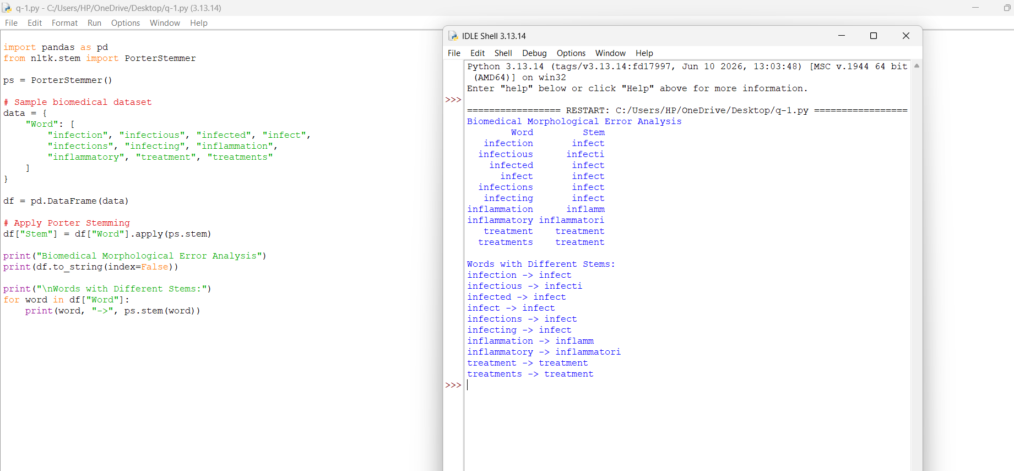

QUESTION 2: Error Analysis of a Finite State Transducer Parser in Social Media Data
Aim
To identify errors in a Finite State Transducer (FST) morphological parser and improve its performance on social media words.
Introduction
A Finite State Transducer is an NLP technique used to analyze words by identifying their roots, prefixes, and suffixes. It uses predefined rules and transitions to recognize word structures. However, social media contains complex word forms, informal expressions, and combinations of multiple affixes that may not be handled by simple parsers.
Error Analysis
Words such as happiest, unbelievable, running, reordering, smartphones, and unreadable contain different morphological structures. A simple parser may incorrectly separate the root and suffix or fail to recognize multiple affixes. For example, unbelievable contains the prefix un- and the suffix -able. A parser that supports only one affix may produce an incomplete analysis.
Causes of Errors
The main causes include missing transition rules, limited vocabulary, incorrect suffix handling, and failure to recognize multiple prefixes and suffixes. Irregular word forms and spelling changes may also create difficulties.
Proposed Solution
The parser can be improved by adding transitions for common prefixes and suffixes. It should support combinations such as un- + believe + -able and re- + order + -ing. A dictionary can be added to recognize irregular forms. The modified parser should be tested on the same dataset as the original parser.
Evaluation
Parser accuracy can be measured by comparing its predicted morphological analyses with manually verified analyses. Accuracy before and after modification can be compared to determine whether the additional transitions improve performance.
Conclusion
FST parsers are useful for analyzing word structure, but their performance depends on the quality of their rules and transitions. Adding suitable affix combinations and irregular-word handling can improve morphological analysis, although excessive rules may increase parser complexity.
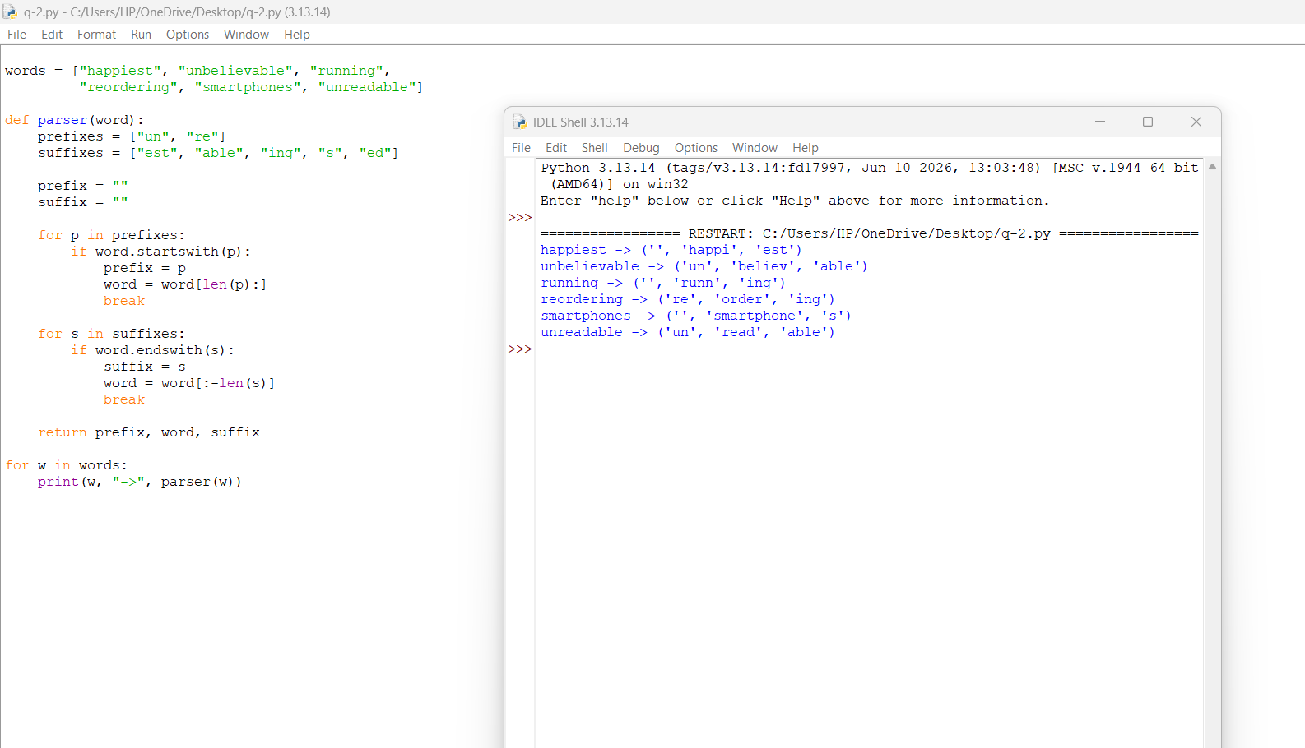

QUESTION 3: Stemming Errors in News Classification
Aim
To analyze the effect of stemming on news classification and compare no stemming, Porter Stemming, and lemmatization.
Introduction
News classification automatically organizes news articles into categories such as sports, business, politics, and technology. Text preprocessing reduces unnecessary variations in words and helps machine-learning models identify important features. Stemming and lemmatization are commonly used techniques, but incorrect word reduction can affect classification performance.
Error Analysis
Consider the words organization, organizer, organizing, organized, and organization's. These words share related forms, but they do not always have identical meanings. Porter Stemmer may reduce them to stems that do not represent proper dictionary words. This can remove useful distinctions between an organization, a person who organizes, and the action of organizing.
Effect on Feature Extraction
Without stemming, each word form may become a separate feature, increasing vocabulary size. Stemming reduces the number of features by combining similar forms. However, incorrect stemming may combine words with different meanings or create confusing features.
Comparison of Techniques
No Stemming: Preserves original words but may produce a larger vocabulary.
Porter Stemming: Reduces vocabulary size but may generate incomplete stems.
Lemmatization: Converts words into meaningful dictionary forms and generally preserves linguistic information better, although its performance depends on the tool and context.
Proposed Solution
The three approaches should be tested on the same news dataset using the same train-test split and classification algorithm. Vocabulary size, classification accuracy, and processing time should be recorded and compared.
Conclusion
Stemming can reduce the dimensionality of news data, but excessive word reduction may affect classification accuracy. Comparing different preprocessing
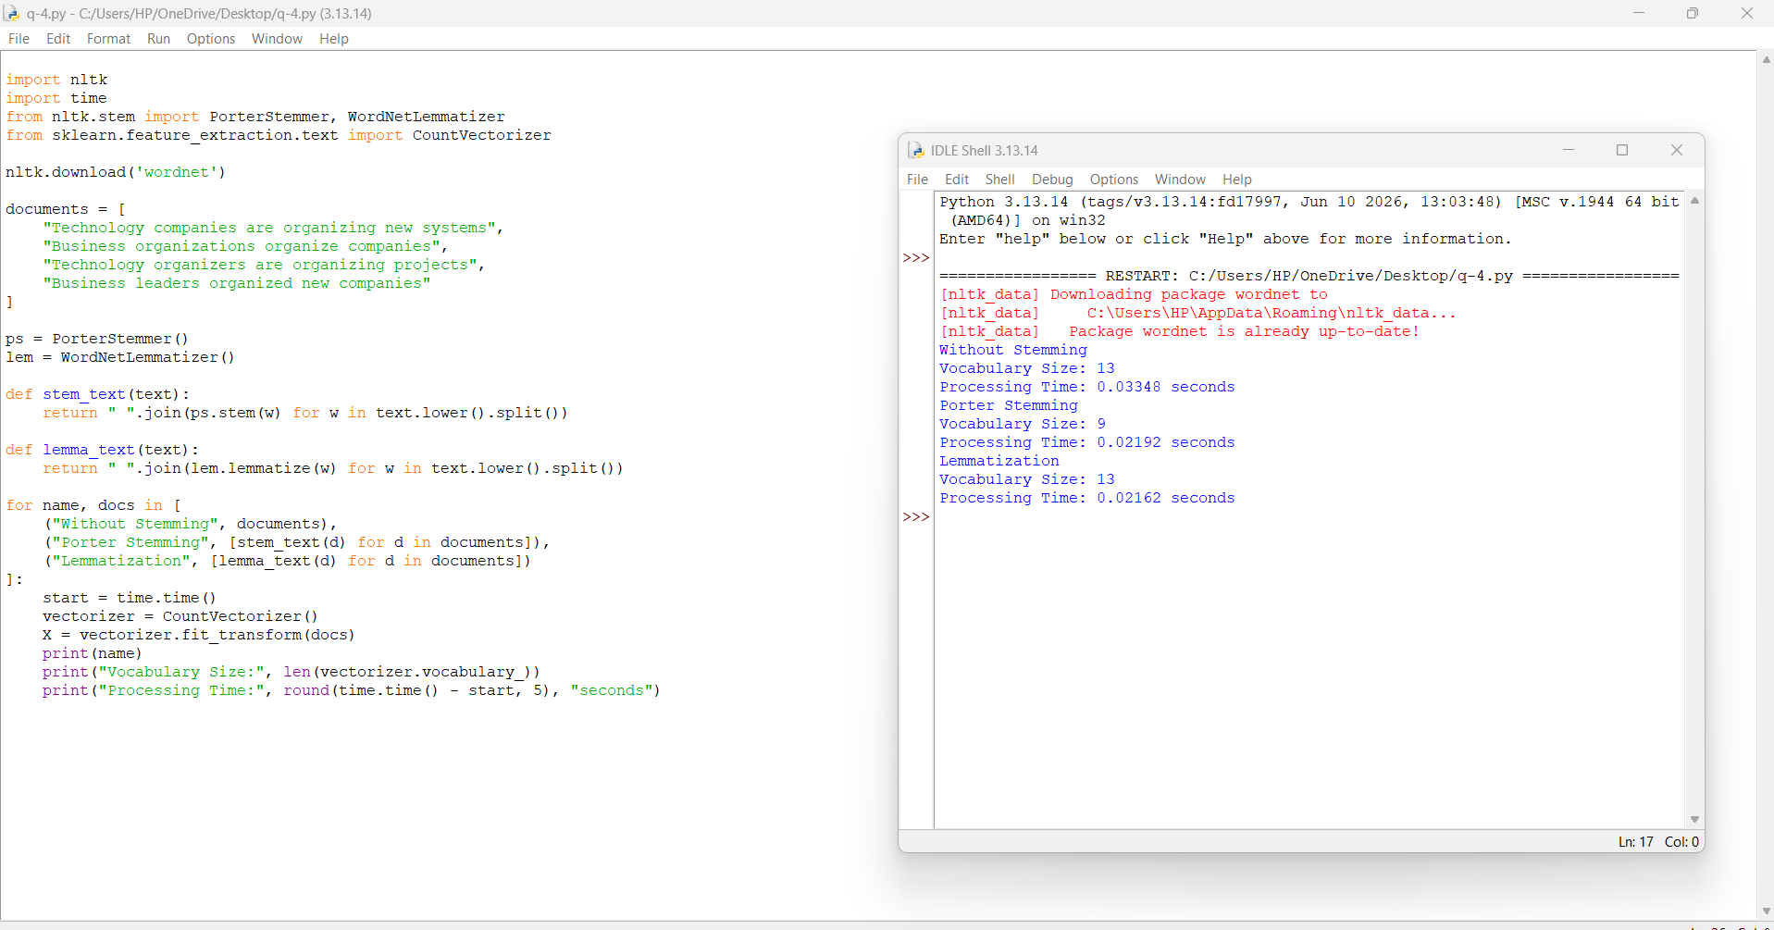

QUESTION 4: MORPHOLOGICAL ERROR ANALYSIS IN INFORMATION RETRIEVAL
Aim
To identify stemming errors in information retrieval and develop an improved strategy for handling inflectional and derivational word forms.
Introduction
Information retrieval systems help users find relevant information from large collections of documents. Search engines often use stemming to match different forms of a word. However, removing suffixes without considering meaning may produce incorrect matches and reduce the relevance of search results.
Error Analysis
Consider the words watches, watching, washable, washer, and washed. These words contain different suffixes and may have different grammatical roles or meanings. A simple suffix-removal method may incorrectly reduce them to the same form or produce an invalid stem.
For example, watching and watched are grammatical forms of the verb watch. However, washer refers to a person or device that washes, while washable describes something that can be washed. These distinctions are important when retrieving relevant documents.
Inflectional and Derivational Morphology
Inflectional morphology changes grammatical features without creating a fundamentally new lexical meaning. Derivational morphology may create a new word with a different grammatical role or meaning. Therefore, removing all suffixes using the same rule may lead to errors.
Improved Strategy
An improved retrieval system should use lemmatization, suitable morphological rules, and a dictionary when necessary. It should preserve meaningful differences between related words instead of combining every form into one stem. Search results should also be evaluated for relevance.
Evaluation
The original and improved approaches can be compared using precision, recall, and F1-score. These measures help determine whether the improved method retrieves more relevant documents while reducing incorrect matches.
Applications
Improved morphological processing can support search engines, online shopping platforms, digital libraries, document retrieval, and customer review analysis.
Conclusion
Morphological analysis improves information retrieval by recognizing related word forms. However, indiscriminate suffix removal can cause semantic loss. Combining lemmatization with suitable morphological rules can improve retrieval quality and help users find more relevant information.
